**Test Message Review Instructions All in One**

Created by: Ying Shen

Updated 1/3/23 by: Katherine Luce

**Contents**

1. Test Message Review Sheet Creation
2. Check MVPS for Test Messages
3. Auto Toggling and Auto Validation
4. Confirm the mis-match data
5. Further investigation

**1 Instructions of Test Message Review Sheet Creation**

When Jurisdictions send the Test Message in MVPS and CSELS confirmed and let NCIRD know**.**

**Step1A**: Save the following documents to **the corresponding jurisdiction folder** here, for example, …\FL\COVID-19. These two documents are from jurisdictions in email.

1. Test Case Scenario Worksheet (TCSW)
2. Implementation Spreadsheet (IS)

**Step1B**: Review the TCSW and ensure there are no empty cells under the Test Records. Across the TCSW, each Test Record variable should be populated in at least one Test Record. Since Test Record 4 replaces Test Record 3, consider these as a pair in the review . Since Test Record 5 replaces Test Record 2, consider these as a pair in the review.

**Step2**: Create a Test Messages folder so that the outputted TM Review Sheet will be under this location.

For example, …\FL\COVID-19\Test Messages.

** For every SAS program, make a copy and save with initials to your specific folder under the shared drive prior to opening. **

**Step3**: Open ***TM Review Spreadsheet Creation.SAS*** (the current version is V3) here, and update the following information on the top of the SAS program.

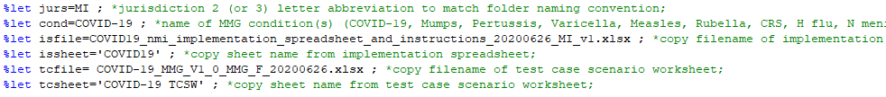

Hit the **run** button.

**Step4**: Compare the number of data elements in the Implementation Spreadsheet from the jurisdiction with the number of data elements within the Test Message Review Sheet output.

Done!

Go to the next page to check the Test Messages.

**2 Instructions of Test Message Check in MVPS and Request to Load**

** Make a copy of SAS program and save to your own folder within the Surveillance folder. Add your initials prior to opening**

**Step1**: Go here and open ***Check MVPS for Messages.SAS.***

**Step2**: Update the jurisdiction code and run the program. Jurisdictions’ FIPS code can be found here.



**Step3**: Make sure the number of Test Messages with current_record_flag=”Y” matches the number in the TCSW and copy the output from **Result Viewer** and save them as an excel spreadsheet in the Jurisdiction Test Message folder here.

For example, …\FL\COVID-19\Test Messages



**Step4**: Send an email to Sang, Akesh, and Samatha and attach the Spreadsheet, asking them to load data from MVPS_ONB to NNAD Staging.

Done!

If Sang/Akesh send back an email, indicating they have finished process data, then go to the next page.

**3** **Instructions of Extract and Validation Automation**

**Form Preparing**

To better understand the logics of the two SAS programs, I highly recommend you read the ***Extract and Validation Automation SAS Program Logics.docx*** saved here and documents a-f in Step0.

**Step0**: Copy the following documents to **your folder**. (You can also run it here, make sure to copy the SAS program and add your initials). For the “MMG for auto”, “DataDictionary_tf_11065”, and “Repeating Model Look Ups” documents, copy the documents from the Prod folder located here. This will provide you with the most updated versions of these documents. If the documents are undergoing a Change Request (CR) (if you are unsure if there is a current CR, ask Sandy, Pam, and Ying), then you can copy the documents from the Dev folder located here.

1. Extract Automation COVID v7.sas
2. [Validation Automation COVID v4 .sas](\\\\cdc.gov\\project\\NIP_Project_Store1\\Surveillance\\NNDSS_Modernization_Initiative\\MMG_Implementation\\Jurisdiction Onboarding\\Test Message Review\\COVID Automation)
3. COVID-19 NCIRD Test Message Review.xlsx

(Make sure the test records you want to compare are named as Test_Record_1, Test_Record_4, Test_Record_5) (we will need to adjust the code if jurisdiction sent separate test records for all 1-5) **Found in the test message folder**

1. [MMG for auto.xlsx](\\\\cdc.gov\\project\\NIP_Project_Store1\\Surveillance\\Surveillance_NCIRD_3\\NMI\\Prod\\Source\\Formats)
2. DataDictionary_tf_11065.xlsx
3. [Repeating Model Look Ups.xlsx](\\\\cdc.gov\\project\\NIP_Project_Store1\\Surveillance\\Surveillance_NCIRD_3\\NMI\\Prod\\Source\\Formats)

**Step1**: Under **your folder**, create a new folder called “**Output**” (The results of the SAS programs will be automatically saved under this folder)

**Step2**: Before move to Step3, open the ***COVID-19 NCIRD Test Message Review.xlsx*** and check if there are equal signs (“=”) or carrots (“^”) in the 5 test record columns, if so, run the SAS program: [Remove_content_after_equal_sign.sas](COVID%20Automation). If there are no equal signs (“=”) or carrots (“^”) and the jurisdiction has provided code only, then skip this step.

Remember to update the directory to where the test message review sheet is saved to.



Remember to define the sign to either sign== or sign=^. You will need to run the SAS program twice, once for the equal sign and once for the carrot.



Remember to revise the input and output file name for each run.



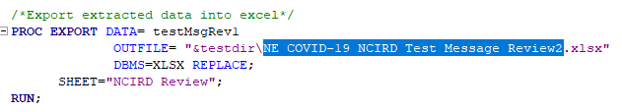

**Extract Automation**

**Step3**: Open ***Extract Automation.sas*** and copy the directory of your folder here:



**Step4**: Tell the **Extract Automation** program your test message form name:



**Step5**: **Close all excel files** Run the **Extract Automation.sas**

After running the program, you will

1. have **DD-extracted.xlsx** under folder Output
2. see a manual toggling report based on repeating models under Results Viewer in SAS (toggle the vars accordingly in the **DD-extracted.xlsx**) **Put 1 in column K to toggle the group**
3. Review the SAS output to see the test records and the corresponding case ID like below:



**Validation Automation**

**Step6**: Open **Validation Automation.sas**. If you are running SAS as a desktop user, ensure provider= “sqloledb”. If you are running SAS as a network user, ensure provider= “sqlncli11”.

libname NNAD OLEDB

provider="sqloledb"

properties = ( "data source"="dssv-infc-1601\qsrv1"

"Integrated Security"="SSPI"

"Initial Catalog"="NCIRD_DVD_VPD" ) schema=NNDSS access=readonly;

Tell the program the **local records id** so that the program will compare var values based on the local record id. The local record id can be copied from the output table in ***Extract Automation.sas*** (see Step5.c). **Test_record1_nnad_n** is same as the **test_record1_nnad** if the local record id starts with characters.

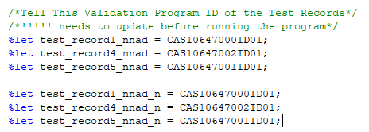

If the local record id starts with numbers, **Test_record1_nnad_n** will need an “_” before **test_record1_nnad** because SAS will generate an “_” when transpose.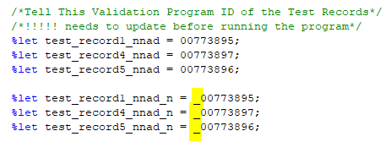

If the local record idcontains “-“, “-“ will be converted to “N” by SAS in the column names. You will need to convert when telling SAS the **Test_record1_nnad_n** (see below screenshot).

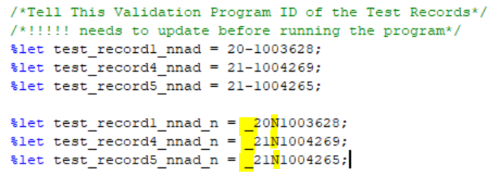

**Step7**: Run ***Validation Automation.sas*** and you will see 2 reports in the Output folder:



**Note:** when look at the ***Validation_Report_Test_Record.xlsx***, make sure all rows without “Y” in column “Match” are reviewed.

When look at the ***Validation_Report_Untoggled_Var.xlsx***, make sure variables with any value for all columns are reviewed.

**Step8**: make sure you archive your outputs here.

All set! Have fun!

For all logics of the two programs, please see ***Extract and Validation Automation Instruction.docx*** saved here.

If you want to confirm the non-match data, go to the next page.

**4 How to confirm the non-match data?**

1. Check the MVPS onboard

**Step1:** Go to <https://mvpsonboard.cdc.gov/>

**Step2:** Go to “Messages”

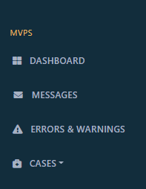

**Step3**: Use filters (e.g., jurisdictions and start date) and click “APPLY”.



If a doesn’t work, then move to b.

1. Check the MVPS Database

**Step1**: Go to MS SQL Server (Sever: DSPV-INFC-1604\QSRV1)

**Step2**: Go to MVPS_ONB -> Views -> hl7_message_meta_vw

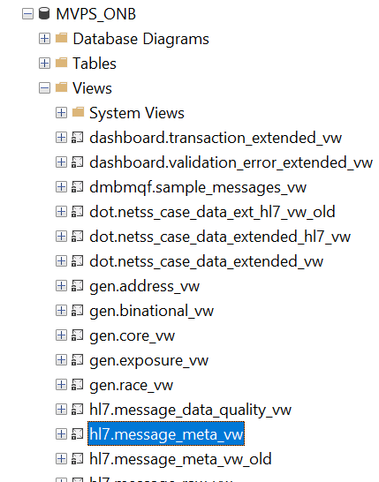

**Step3**: use the following codes to get the raw message

select raw_message

FROM [MVPS_ONB].[dashboard].[transaction_extended_vw] a

left join [MVPS_ONB].[hl7].[message_meta_vw] b

on a.trans_id =b.msg_transaction_id

where b.local_record_id ='CAS11623003KY01' and b.current_record_flag='Y'

**Step4**: copy the raw message to a word doc because it could be multiple-page long.

Have fun exploring!

Please see the Appendix for Information on matching the transaction ID to the correct test record.

If you want to further investigate the issue in both MVPS and NNAD, go to the next page.

**5 Process of Test Message Investigation NNAD**

1. Confirm the case in MVPS: Go to <https://mvpsonboard.cdc.gov>

Search the data element name

1. Go to staging in SQL Server

|  |  |  |
| --- | --- | --- |
| **DATABASE ENVIRONMENT** | **SQL SERVER NAME** | **SQL DATABASE NAME** |
| **NNAD:** | | |
| Staging | DSSV-INFC-1601\QSRV1 | NCIRD_DVD_VPD |

1. Go to stage2: Stage2_MVPSCases

The answer is in obx_5

The data element is in obx3.1

The local record id is in INV168

SELECT TOP (1000) [ID]

,[trans_id]

,[msh_id]

,[NOT116]

,[INV168]

,[INV169]

,[INV166]

,[WSYSTEM]

,obx_3_1

,obx_3_2

,obx_5

FROM [NCIRD_DVD_VPD].[NNDSS].[Stage2_MVPSCases]

where INV168 in ('CAS10647000ID01', 'CAS10647002ID01', 'CAS10647001ID01' )

and trans_id = '751347'

and obx_3_1 ='309904001'

1. Go to Stage3

SELECT TOP (1000) [trans_id]

,[condition]

,[mmwr_year]

,[report_jurisdiction]

,[local_record_id]

,[site]

,[wsystem]

,[dup_SequenceID]

,hosp_icu

,res_type

FROM [NCIRD_DVD_VPD].[NNDSS].[Stage3_NNDSScasesT5]

where local_record_id in ('CAS10647000ID01', 'CAS10647002ID01', 'CAS10647001ID01' )

1. Go to Stage4

SELECT TOP (1000) [trans_id]

,[condition]

,[mmwr_year]

,[report_jurisdiction]

,[local_record_id]

,[site]

,[wsystem]

,[dup_SequenceID]

,hosp_icu

,res_type

FROM [NCIRD_DVD_VPD].[NNDSS].[Stage4_NNDSScasesT5]

where local_record_id in ('CAS10647000ID01', 'CAS10647002ID01', 'CAS10647001ID01' )

1. Done! Take any screenshots if needed.

# **Appendix:**

**Matching the Transaction ID to the Correct Test Record Using MVPS Raw Message Data**

Updated on 2-11-2022

**Instruction 1: Introduction**

**Step0:** Checking the correct MVPS raw message data for the jurisdiction Test Message (TM) Review is completed before Instruction 5: Process of Test Message Investigation in the Test Message Review Instructions All in One.

These instructions will help the user to understand how to find the corresponding MVPS raw message data to the correct Test Message Record. This will allow for correct verification of the raw message data while completing the Test Message Review Investigation.

These instructions can also be used in any situation where the user has either the MVPS raw message data and would like to find the correct test message record or has the Test Message Transaction ID and needs to find the corresponding MVPS raw message data. In these instructions, the user will be using Transaction ID as well as Case ID.

**Step1**: Open the “**Test Messages in MVPS_ONB**” located in the Jurisdiction Test Message folder here. Copy the Transaction ID located under the column: msg_transaction_id for the messages with the current_record_flag=Y.

**Step2**: After copying the Transaction ID, go to the MVPS Onboarding Portal located here: [MVPS Portal (cdc.gov)](https://mvpsonboard.cdc.gov/)(Chrome Browser works best). Click on the messages tab.

**Step3**: Using the msg_transaction_id number found in the excel spreadsheet from the “***Check MVPS for Messages_TM.SAS”***, paste the Transaction ID into the search bar (be sure to select Transaction ID). Be sure to adjust the dates to the include the timeframe that the jurisdiction sent the messages and a MVPS message to match the specifications will load.

**Step4**: Open the message in the MVPS Onboarding Portal from the jurisdiction and copy the Case ID number. In the example picture below, the Case ID is 159211779.

**Step5**: Open the TCSW from the Jurisdiction located here and search for the Case ID number. The Case ID will be listed under a Test Record. This will show you which Test Record corresponds to the MVPS message.

The Case ID will correspond with one Test Record and one Transaction ID. If the Case ID is listed twice in the TCSW, it is listed under a duplicate Test Record. Test Record 4 replaces Test Record 3 and Test Record 5 replaces Test Record 2. Transaction IDs of current record “Y” should correspond with Test Record 1, 4, and 5.

Done! You can now complete the TM Review Investigation using the correct raw message data for each Test Record.